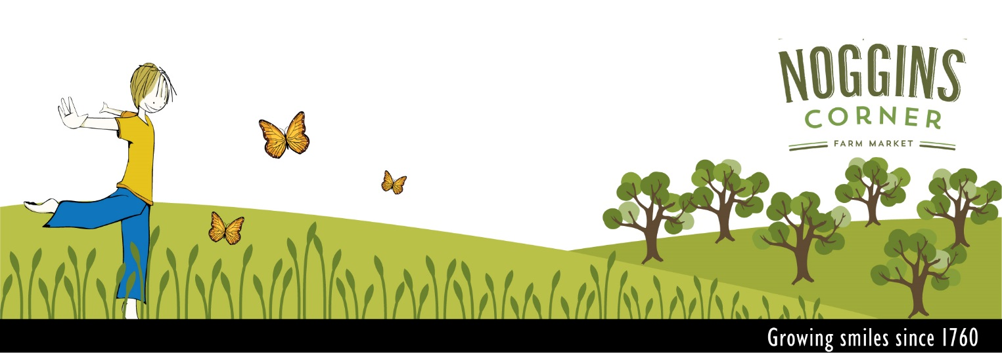
Spring Field Trip Reservation Form
Noggins Corner Farm
www.nogginsfarm.ca
10009 Highway 1 Greenwich, Nova Scotia B4P 2R2
tours@nogginsfarm.ca
Office: (902) 542-5515 ext. 23
Fax: (902) 542-1791

Please Note:
- YOUR RESERVATION IS NOT COMPLETE UPON SENDING THIS FORM. Once you receive a confirmation email, phone call or fax from our office, your reservation is confirmed.
- We operate on a first come, first serve basis. Priority will be given to complete reservation forms.
- Please fill out all fields marked with an asterisk (*)
- Once your form is complete, please email or fax it to the contact above!

Contact Information:

*Name of School:
*School Phone Number: *School Fax Number:
*School Mailing Address:

*Organizing Teacher’s Full Name:
*Main Phone Number: Personal Phone:
*Teacher’s Email:
*Preferred method of contact:

About Your Visit:

*Preferred Date Requested:
*1st Alternate Date:
*2nd Alternate Date:

*What Grade(s) Will Be Attending?:

*Please give the name of each teacher, their grade level and number of students for each class that will be attending: (this is important for us to plan your day at the farm)
Example: Mrs. Brown: grade 4, 22 students. Mr. Black: grade 2/3, 17 students.

*Number of Chaperones Attending:

We allow 1 chaperone for every 5 students to attend for free. Teachers, EAs and school staff are not counted as part of this ratio. Additional chaperones will be expected to pay the student price of $6.50 per individual.

*Will EXTRA chaperones: Pay on their own upon arrival?
Be part of monies collected by teachers?

*Arrival Time: *Departure Time:
Our tours typically run for 3.5 hours. This includes all educational programming and time for lunch and playtime. We are very flexible for start times and any time considerations you may have.

Which specific program are you interested in? We are happy to mix and match based on your request! Simply check more than one box if you’d like us to touch on several subjects and explain your specific goals/ideas below:
Please see our program brochure on our website for a complete description of each program!

*Program Choice:
Primary-Grade 1: Awesome Bees and Super Seeds
Grade 2-3: Wetlands and Ponds – Learning to protect our swampy friends
Grade 3-4: Soil – Exploring a precious resource
Grade 3-4: Habitats – Who lives where?
Grade 5-6: The Food Chain – Who is a predator and who is prey?

*Specific Goals:

Mode of Transportation: Method of Payment:

*Please let us know if you have individuals with special considerations (i.e, dietary, mobility, learning) so we can help everyone have a great day at the farm:

Questions, comments or other details we should know! :

Thank you for your reservation!

